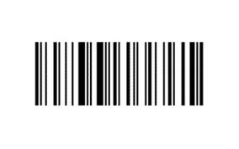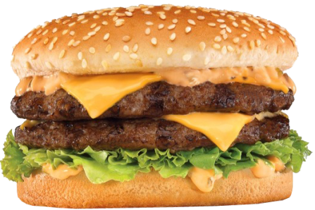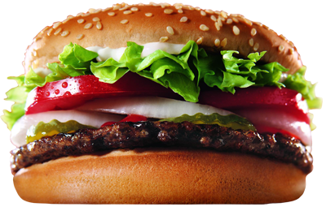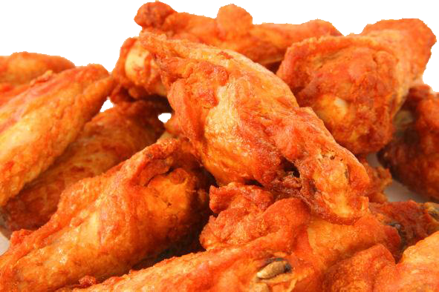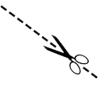

Valid Only At S-Mart

Valid Only At S-Mart

*Ground Beef*

Buy 1 Get 1 Free

*Treat Yourself*

**Restaurant Coupon Template**

*Treat Yourself*

*Ground Beef*

Buy 1 Get 1 Free